Se o erro for esse: fatal: refusing to merge unrelated histories

Usar isso: O erro é resolvido alternando a opção *permitir histórias não relacionadas* . Após um comando git pullou git merge, adicione a seguinte tag:

git pull origin master --allow-unrelated-histories

Se o erro for esse: error: Pulling is not possible because you have unmerged files.

hint: Fix them up in the work tree, and then use 'git add/rm <file>'

hint: as appropriate to mark resolution and make a commit.

fatal: Exiting because of an unresolved conflict.

Usar isso: Git merge -–abort

Se o erro for Esse: ! [rejected] master -> master (non-fast-forward)

error: failed to push some refs to 'https://github.com/renansalvino/1s2020-t2-sprint-2-backend-peoples.git'

hint: Updates were rejected because the tip of your current branch is behind

hint: its remote counterpart. Integrate the remote changes (e.g.

hint: 'git pull ...') before pushing again.

hint: See the 'Note about fast-forwards' in 'git push --help' for details.

Usar isso: $ git fetch origin

Perguntar sobre:

Git fetch

Git merge

Git diff

ver se funciona mesmo os comandos que eu estudei

Deu certo

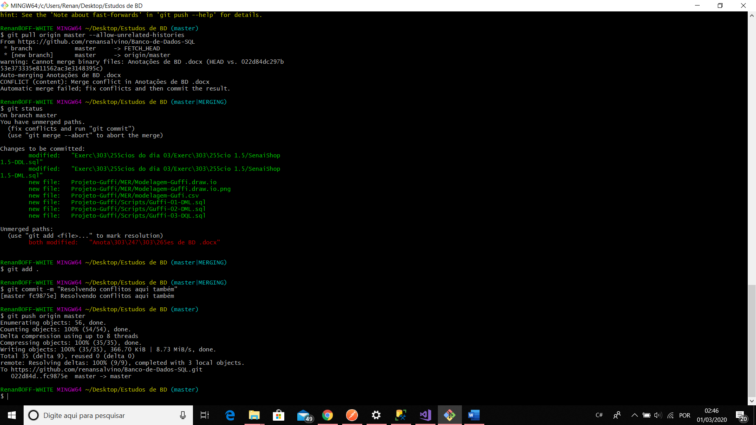

Resolvendo conflitos de outra maneira:

